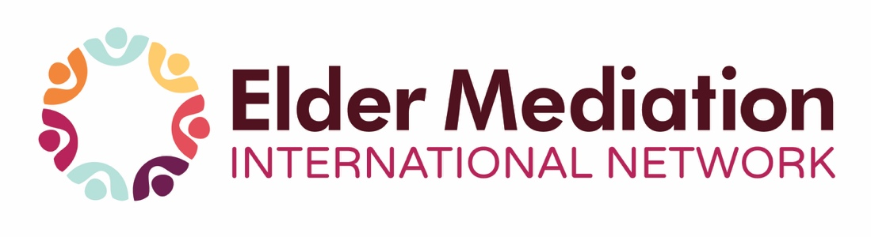

EMIN 12th World Summit – “Program at a Glance”
UCC (Gateway Bldg) Cork, Ireland May 20-22, 2026
DATE | PRESENTER | TOPIC | FORMAT
May 20 | Siun Kearney  (Ireland) | Reflections of an Irish Mediator | Presentation
 | Kimberly Leonard (Canada) | Aging Well in the Right Place: Expanding Elder Mediation Services | Presentation
 | Relationships Australia | Centered Voices, Connected Systems: Elder Mediation as a Human Rights–Based Response to Abuse & Mistreatment of Older Adults | Video
 | Judy M. Beranger | Elder Mediation: Changing the Face of Health Care, Social Care and the Legal Landscape | Presentation
 | RECEPTION - LORD MAYOR | Bus provided for a reception at Cork City Hall
May 21 | Prof. Patricia Kearney (Ireland) | Insights from The Irish Longitudinal Study on Ageing (TILDA) | Keynote
 | Vesna Cvjeticanin (Australia) | Mediation Crosses Paths with Culturally Diverse Elders in Australia | Presentation
 | Corinne Weis & Claudine Heuschling (Luxembourg) | Luxembourg’s National Service for Information and Mediation for Older People | Presentation
 | LUNCH PROVIDED | Onsite at University College Cork
 | Freddie De Luca (United Kingdom) | Addressing the Balance of Power Through the Lens of Family Dynamics in Elder Mediation | Presentation
 | Frances Stephenson (Ireland) | Intergenerational Dynamics Through the Compassionate Lens of the Elder Mediator | Presentation
 | Dr. Dale Bagshaw (Australia) | Safeguarding Vulnerable Adults: Strategies to Enhance Decision Making | Video
 | Helen Harnett (Ireland)  Rhonda Whitfield (Australia)  Dr. Fredrick Aoko (Kenya)  Illona Kupp-Lieck (France) | Panelists will reflect on the key issues shaping the lived experiences of older adults and their families in their home countries. They will explore how these issues are shaping Elder Mediation practice, highlighting the role of the EMIN Elder Mediation Code of Ethics in their country. | Panel Presentation
 | Awards and Presentations | Reception - Historic Room at  University College Cork
May 22 | Mick Comyns  (Ireland) | Crime and Elder Abuse Relating to Elder Mediation - A Policing Perspective | Presentation
 | Prof. Mary Donnelly (Ireland) | The Role of the Assisted Decision-Making (Capacity Act 2015) | Presentation
 | Patsy Fitzsimons (Ireland) | Mediation in Investigating and Resolving Complaints in the Decision Support Service | Presentation
 | Cabrine M. Lwandeka  (Uganda) | Challenges of Mediation with  Age in Uganda | Presentation
 | LUNCH PROVIDED | Onsite at University College Cork
 | Kay Adams  (United States) | The Impact of Dementia on Intergenerational Family Dynamics and Conflict | Presentation
 | Shona Tostevin (Australia) | Resolving Care Planning Disputes in South Australia | Video
 | Tadgh Daly  (Ireland) | Nursing Homes in Ireland | Presentation
 | Mags Bouchier (Ireland)  Yue-En Chong (Singapore)  Helen Clarke  (New Zealand)  Melanie Mueller (Germany) | Panelists will reflect on the key issues shaping the lived experiences of older adults and their families in their home countries. They will explore how these issues are shaping Elder Mediation practice, highlighting the role of the EMIN Elder Mediation Code of Ethics in their country. | Panel Presentation
 | Perpetual Motion Choir | Parkinsons Ireland  - Cork Branch | Choir
 | Judy M. Beranger (Canada)  Siun Kearney  (Ireland) | Reflections & Takeaways  Next Summit | Wrap-Up
 | Freddie De Luca  (United Kingdom) | Summit Closing | Closure

