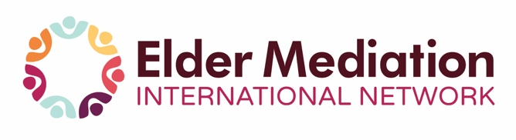

10th World Summit on Elder Mediation
Virtual Event – Call for Presenters

November 1 - 2, 2021

WORLD SUMMIT AIMS
The Summit aims to provide participants with a comprehensive, international overview of Elder Mediation and an opportunity to learn about established initiatives in this field.
SUMMIT GOALS
- To increase awareness of Elder Mediation and its benefits.
- To build the knowledge base of practitioners and policymakers.
- To highlight examples of research and best practice in Elder Mediation.
- To facilitate dialogue between mediators, other professionals, representative groups and older people, with a focus on the opportunities and challenges of providing Elder Mediation.
- To provide a set of practical options for facilitating equal opportunities for older people to participate in decision-making and consultations.
- To provide opportunities for networking.
ABSTRACTS
The Summit Steering Committee invites participants, who are registering for the 2021 Virtual Summit, to submit an abstract for consideration to provide a 30-minute live presentation during the event. Consideration will also be given for submissions from presenters who wish to record their session in advance and then have it shown at the Summit. The abstracts will briefly and clearly name the title and describe the presentation. Any contribution to the field should be noted along with any Elder Mediation research and practice experience. Please include past speaking experience and knowledge in relation to the topic. (N.B. The topics that will be presented at the Summit can be counted toward credit hours for Elder Mediation certification.)
SELECTION PROCESS
The Selection Committee will access and select potential conference presentations based on individual merit and determined by the overall quality, importance and relevance of the content. All abstracts will be assessed by a selection committee and the author(s) will be advised of the outcome.
DATES
Call for presenters opens: March 23, 2021
Deadline for submissions: ASAP (August 15, 2021 deadline)
Notification of acceptance by: Within 30 days of receipt of submission
SUBMISSION FORM FOR ABSTRACT AND BIOGRAPHY
Name:
Job Title:
Organization:
Address:
Email:

Please include:
Abstract of your presentation (max. 250 words)

Brief Biography (max. 250 words):

Send abstract to: summit@elder-mediation-international.net
This year’s Summit is a virtual event accessible to registrants from around the globe in diverse time zones. It is our intent to record all sessions in order to stream them afterwards to all registrants during a one-week period following the completion of the event. Submission of an abstract constitutes permission to record and share your session if it is accepted for the Summit.
Do not hesitate to let us know if you have any comments or queries with regard to the Summit.
Thank you,
Judy Beranger
Chair, Summit Planning Committee

